# Digital Technologies – Web Application and Report

# Assignment 2 – Website Design

To decide a topic, I decided to look on a Discord server to see what the other University students were making the portfolio site on. Most people decided to do their sites on their 3D models they have previously made, however, I am new to modelling so I haven’t made enough to make 3 pages. So, I decided to do the portfolio site on a group I’m heavily involved in, the Furry Community.

## Required Research

For creating the site, I knew a fair amount thanks to previous school and college work. However, I did need the use a couple of websites to help with some of the code. Used to find out how to create lists (1) or how to add a slide show (2).

I genuinely had most of the required research for the information on the site anyway before going into this assignment, so I did not need to do too much research into the community. However, I did end up researching a couple of sites to do with certain characters and custom-made species, etc.

### Sites Found

1. - Creating Lists - <https://www.w3schools.com/html/html_lists.asp>
2. - Creating a Slide Show - <https://www.w3schools.com/howto/howto_js_slideshow.asp>

## Issues Found

One of the issues I found was with the content as I needed to find high quality photos on the internet. Luckily, I did manage to find some on Google and use a couple of my own work that I previously designed myself.

I did have some issues with designing the site. One being the header, whenever I would add something new, it would appear behind the header itself. I added some code to freeze the header in position, but instead it just allowed stuff to be put behind it. I managed to fix this issue by removing the tag to freeze its position. This then allowed all the other elements to be pushed bellow rather than behind the object.

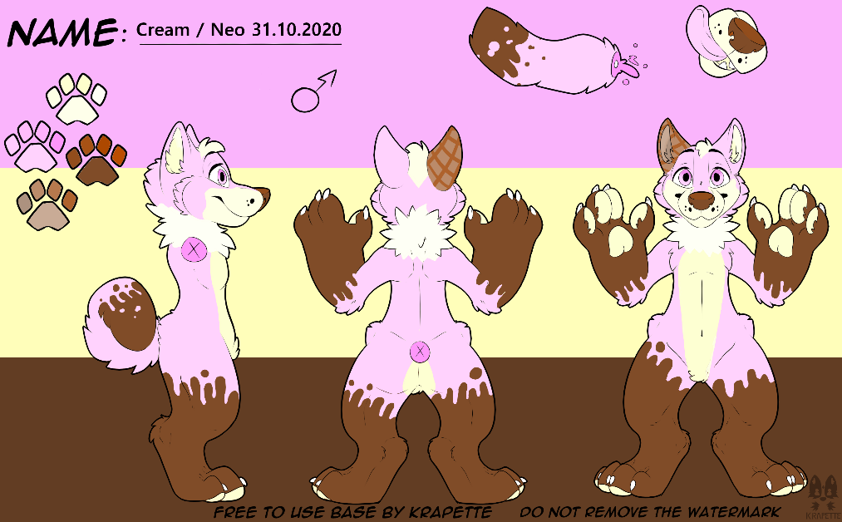

Image found on the “About” and the “Sonas/Personas” pages.